**CP3407** ASSESSMENT TASK 2: **Project part-2**

**Team Information**

Github: <https://github.com/myth002/CP3407_A1> (Private repository)

Website: <https://myth002.github.io/CP3407_A1/orders.html> (Public website)

**Team Members:**

Anumolu Sandeep Prasad (13156974)

Role: Team Leader

Udaya Bhaskar Reddy Malkannagari (13368171)

Role: Lead Designer

Fadni Harisyam (13269323)

Role: Lead Researcher

**Project Briefing**

**Company Background**

K-Market PTE. LTD, is a wholesale trading business established in the year 2006 focusing on trading groceries to restaurants in Singapore.

The company was bought over by the current directors in 2012 to expand the ongoing trading business.

**Company’s Business Growth Plan**

Due to constrain in generating revenue solely from restaurants was a uphill task. The revenue from restaurant business was having a downtown in 2016 due to tough competition from new entrants to the business who were undercutting which causing price war among the existing trading companies.

Labour shortage contributed to the closing of many restaurants which made it difficult to collect our payment dues.

In 2017, we decided to shift our focus from the restaurant to providing groceries to established hotels as we saw growth in visitors from the Asian region. This noticeable growth of tourists consuming Asian food opened the opportunity to expand our business.

Being a certified Halal trader, we were able to penetrate various hotels in Singapore to offer dried Asian groceries.

**Project Title**

Development of *K-Market*wholesale application to increase productivity and revenue.

**Project Goal**

Implementation of cloud based on the ERP (Enterprise resource planning) is the main aim of industry norms/practice for managing the inefficient/challenges in the current workflow/process. This application is used to increase the productivity, revenue, quality of the K-Market wholesale trading company. This application has inventory, supplier, customer, accounts, reports, user, settings in which it maintains the productivity.

**Current State of Business Operations and Process**

The current process of handling customer orders is via fax and telephone where the orders are written on papers for further processing. The ordered inventories are gathered in the assembled area for packing and an invoice is generated using desktop invoicing system.

The items are countered checked against the customer orders and released for delivery. The items are then delivered to respective hotels based on the ad-hoc trip arrangement which is manually monitored by the management.

Customer Orders

Ordering

Delivery

Accounting

Inventory

Operation

The current process of handling business is in such a way that customer orders the product via fax and telephone where the orders are taken in the form of papers in case of emergency for further processing. The ordered inventories are grouped together in the assembly area for packing to deliver to the respective customers on mentioned date and an invoice is generated using desktop invoicing system.

The ordered products from the customers are again cross checked before packing to increase the effective, efficiency and reputation of company and released for the delivery. The items are then delivered to respective hotels based on the ad-hoc trip arrangement which is manually monitored by the management.

When customer orders a product the operations department gets the required product from the inventory, so they could carry on with packaging and delivery. The operation department should also handle the purchase of goods for the inventory and manage the sales. The accounting department gets the information from the operations, files it and handles the financial records.

**Justification**

Inefficiencies from the current workflow of business have made operations time-consuming and protracting.

We have gathered a list of said inefficiencies which are in dire need of a new solution;

Products are missed out, including wrongly identifying the product, by employee who answers the call.

Order is written down on paper which is often misplaced.

The chances of packing other customer products are high.

Expired items are not noticed by employee before packing.

Shortage of labours to pack the products to deliver to the customer on right time.

Then the important challenges in current workflow process is to ascertain safe delivery to the customer.

The solution we are proposing will cover all issues mentioned above and increase revenue for the company

**Solution**

The *K-Market* application is a web-based application that will replace the current operation and remove any challenges hindering the service. As of now, major features of the application will include *Inventory Management, Account* page for customers and staffs, *Online Ordering,* and *Online Payment.* We have compiled a comprehensive table of containing a comparison between the current and the predicted time consumption if we were to implement this solution

|  |  |  |  |
| --- | --- | --- | --- |
| **Before project** | | **After project** | |
| Process | Time/Cost/ Space/ manpower required | Process | Time/Cost/ Space/ Manpower required |
| Manual order taking | 20 mins | Application based order | 10 mins |
| Manual inventory list | 15 mins | Application based inventory list | 5 mins |
| Manual Payment | It depends on the customer he pays | Online transactions | Within a minute |
| Manual Accounting | 30 mins/3-4 mem | Automated Accounting | 5mins |
| Manual reports | 1 hr/ 2 mem | Automated reports | 20 mins |
| Manual management | May vary due to range of company | Application based management | Remains constant even if company expands |
| Manual setting of some sub functionalities | Hardly need higher official to give permission | Application Based setting | Can be permitted by using app |
| Managing the entire process by manual | Required more salesman and employees | Automated based process | Required less men to manage |

To achieve this goal, we plan to design a website that can be managed personally as it is convenient and user-friendly. We will use HTML and CSS to customize the content of our website. Hands-on programming requirement are still met since we will use JQuery and JavaScript to modify the website. All data submitted from our website such as registration information, login credentials, restaurants and other relevant data can be viewed from the database.

**Features**

Herein, we list out all the features incorporated in our final design. These features are designed in such a way that they meet all of our customer’s core requirements and enhance the usability of the product. The design is kept simple and clutter free in order to improve navigation and readability.

**1. Home Page**

The Home page will be the landing page for all visitors. As with all other pages, this page can navigate the user to the other pages on the website. The client will be able to login into their account through this page. The page has the option to register separate users for different logins. This way, the data can be entered locally and simultaneously by different users to keep an updated database of all the transactions and orders.

**2. Inventory Page**

The Inventory page displays a comprehensive list of all the items currently in stock. Items can be added or removed using clickable buttons. A brief description of the item, along with the item id, item type, current orders and total orders will be displayed on the right-hand side in a rectangular box format. Product information is as concise as possible. All items will be categorized accordingly to avoid confusion, and staffs can also manage the inventory easily by adding and removing items whenever necessary to reduce inaccuracy in the packaging process.

**3. Customer Page**

The Customer page will display a table of all registered restaurants’ current and previous orders, including its payment status. We will also include an ID for each restaurant to avoid misinformation. We made this page to keep our staffs up to date to the most recent orders, so they can do their job more effectively. The content of the table will be updated automatically as it is linked to our database system to avoid confusion among employees.

**4. FAQ Page**

This page will contain a list of frequently asked questions. We decided this page to be static because we want it to be as user friendly as possible, seeing that the number of questions aren’t very numerous. And like other pages, this one can access all features of the website.

The FAQ provides basic information about the ordering procedures and the time taken to process orders. It also details a brief summary of the mode of payment and other relevant information regarding the products and services offered.

**5. Order now Page**

In the ordering page, customers will have to complete a form containing all necessary information about the order, such as their customer id, the item ids of the selected product, the number of orders, the amount of the order and its preferred delivery date. After the customer submitted the form, it will be sent directly to our database and can be viewed on our end.

This page details a list of all the products including their prices. The customer can also check the total payable amount based on their selected orders. The mode of payment is also displayed as a scroll down menu that offers various payment options to the user. The customer can fill in their restaurant details including their address for quick processing of their delivery.

**6. Support Page**

The support page will display a set of information needed to contact us, not limited to our current complete address, telephone number if you wish to speak to us directly, fax number, and our email address should the customer would like to make an inquiry. Despite the simplicity of this page, it serves its purpose and works as how we proposed it will be.

**Deliverables**

The assignment will be submitted to the lecturer as a zip file containing all files related to the assignment. Files may contain a link that will redirect to an external website crucial for marking.

**Delivered Alpha Release**

[**https://myth002.github.io/CP3407_A1/**](https://myth002.github.io/CP3407_A1/)

**User Stories**

Order now

Description: Clients can submit orders & payment information through the website.

Effort Days: 2 Day

Home Page

Description: Users will login to the website and have privileges according to its account type

Effort Days: 2 Days

Inventory Page

Description: Users can view and manage the content of the warehouse, including but not limited to adding and removing items

Effort Days: 2 Days

Customer Page

Description: Users with the proper privilege can see on-going and previous orders of registered clients.

Effort Days: 2 Days

Support Page

Description: This page will contain all relevant information for website visitors to contact us.

Effort Days: 1 Day

FAQ Page

Description:       This page will provide user guidance in accessing our website and making orders and

                          payments.

Effort Days:        1 Day

We had attempted to achieve our goal as close as possible to our planned user stories. And we think that we had done just that. We delivered the product as how we wanted it to be in most aspects; Architectural Structure and Design Structure wise. Our external database will have a sufficient functionality to store all crucial information relevant to our project. Apart from the added SQL database, we do not have any alterations affecting the first iteration of the release. The database serves the purpose of storing relevant and crucial information on the client’s customers, products, and users.

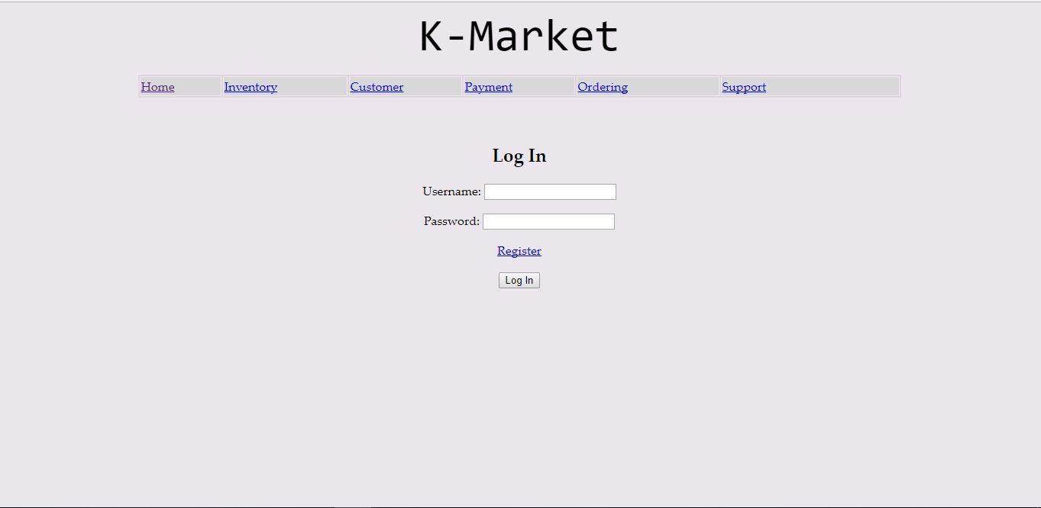

The above screencap shows us the login home page of our client website, where they will be able to enter their user credentials to login to their own personalized online storefront to manage orders and inventory. Next to it, the inventory management section of our website is where our client will be able to manage their distribution service and grocery stock to set up delivery schedules. The privileged users will have access to view restaurants registered on our client website that is stored in a database with their past and current orders and interactions with the client.

The new addition, F.A.Q page, serves the purpose of quickly answering end-users who are bound to have many queries which this page hopes to alleviate. We also have a graphical statistical analysis of the end-users who have registered on the website as well as monetary analysis. Not unlike, the Contact Us page is also a static page that functions as a mean for end-users to find contact information and the location of K-Market’s retail outlet(s).

**Acceptance Testing**

During one of the practicals, our group conducted a live testing of the alpha release with a purpose of spotting any minor bugs or any unfulfilled user stories. The testing was supervised by our lecturer and we presented the release as is. Present features work as intended, including but not limited to;

Each page allows user to navigate to all pages using the menu bar

Javascript, JQuery works properly in the order form, the application was able to automatically calculate the total of selected items from the table.

Input fields are writable, each with their corresponding data types.

The acceptance testing underwent without any difficulties, and the lecturer was able to use our release, and explored all features within it without any difficulties. The test took place about a couple of minutes.

**Details of the Usability testing:**

**Usability Testing 1:**

The client wanted the inventory to be managed and streamlined based on the items ordered. The inventory page serves this purpose by giving a detailed description of the item ordered along with the number of orders made. A screenshot of this is given below.

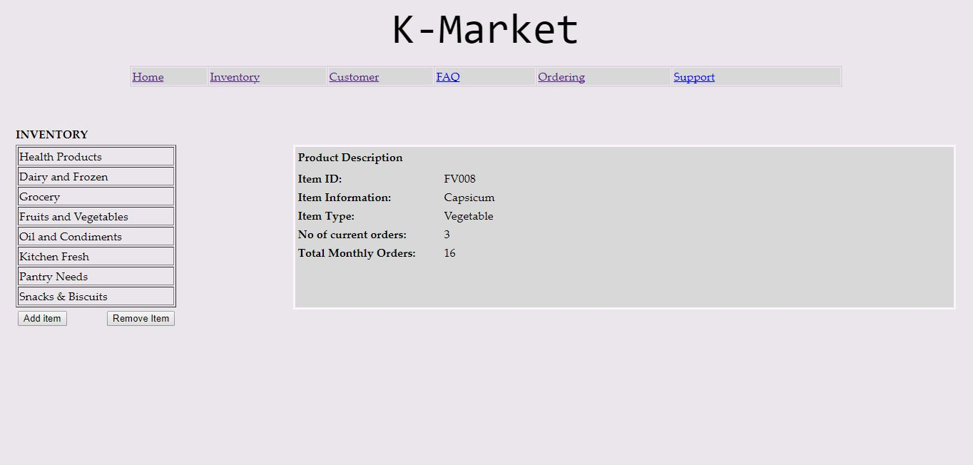

Number of orders are also updated to the user database. The client can access the database and query for the items based on the number of current orders. This requirement is explained in the screenshot of the database below. It displays the restaurant name along with the item ordered and the current orders.

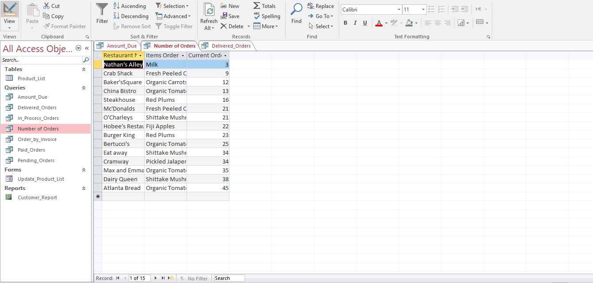

**Usability testing 2:**

The client wanted to to order items based on their prices. This feature was implemented in the website using Jquery. the client will be able to see the total price of the items ordered as well. The client can select different items based on personal choices and input the number of items required. The total price of the items will be displayed in the ‘Total Price’ field as shown in the figure below

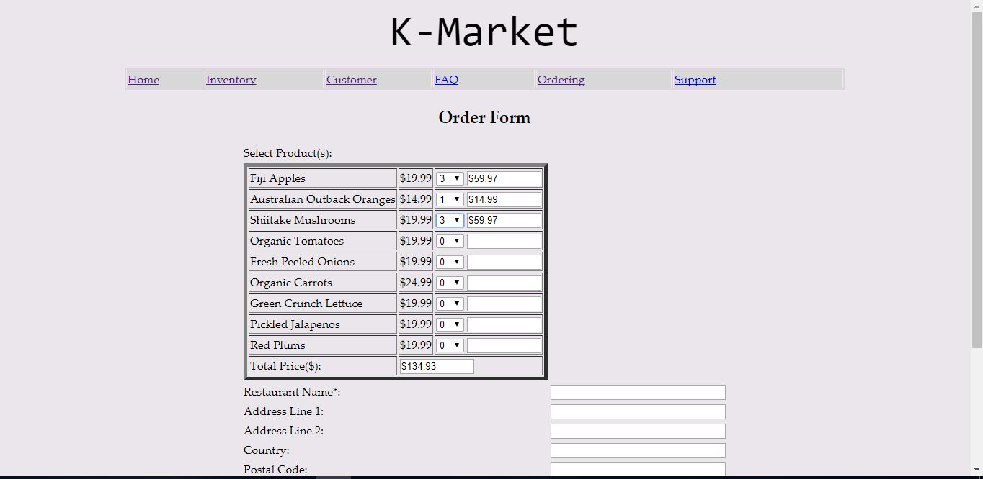

The client database will be able to generate the amount due based on the payment status. The client can check if the payment was received or it is still pending. The client can also filter out the paid items with the unpaid items. This is observed in the screenshot of the database below.

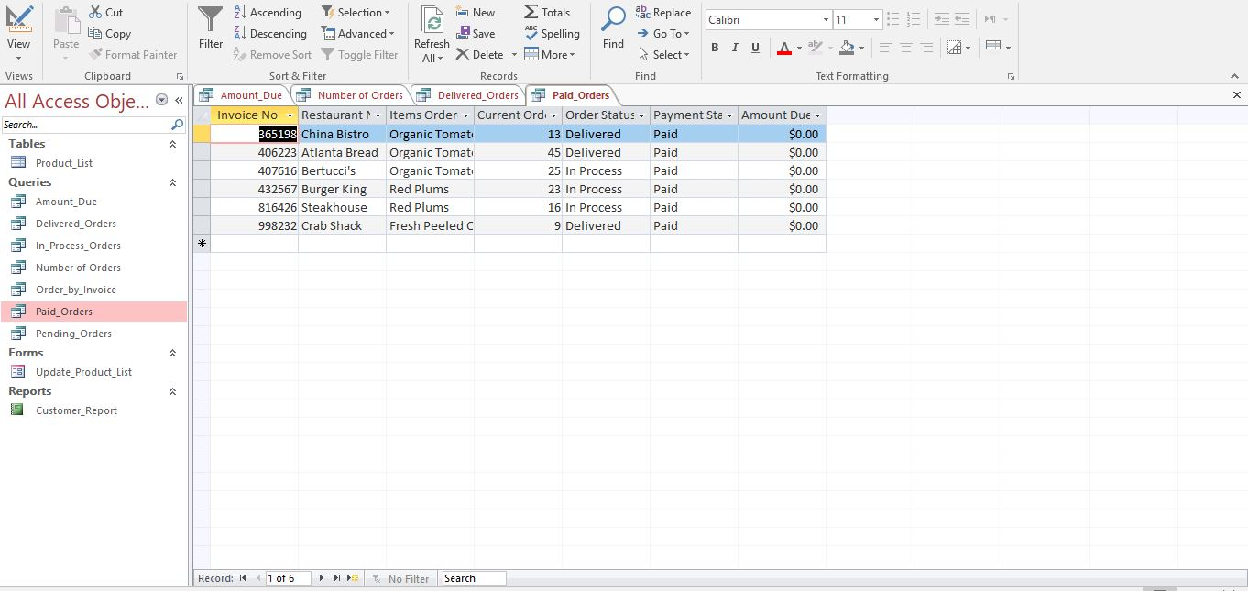

*Figure: Filtering the paid orders within the user database*

The client can also access the amount due in the user database. This value can be queried and sorted from the highest to the lowest as shown in the figure below.

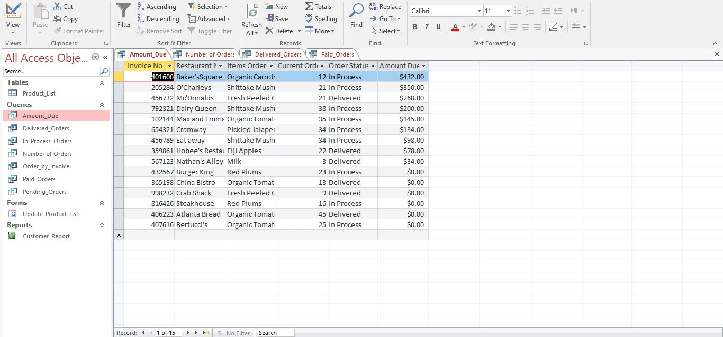

*Figure: Showing the amount due for each order*

**Usability Testing 3:**

The client wanted to check for the status of the products delivered. This was incorporated in the database client. The database will be constantly updated of the status of the product ordered. This status can be either delivered or In process. The client will also be query and filter the status of the delivered product. This gives the client an improved control in providing logistics to the supply food chain. It will greatly enhance the inventory management of the user database.

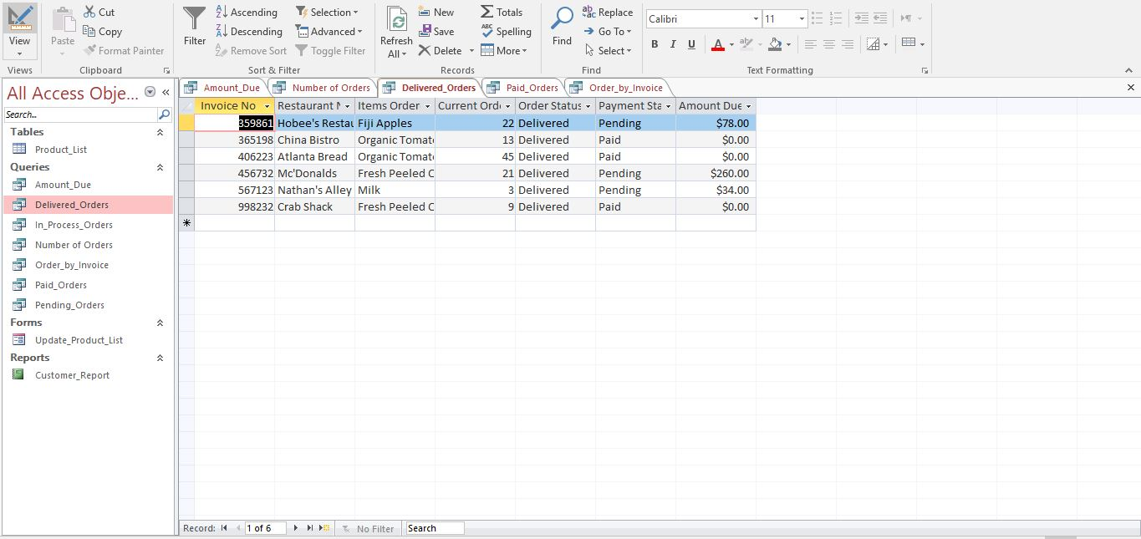

*Figure: Showing the status of the orders as ‘Delivered’*

**External Software Libraries**

We used a separate MS Access as our database, that serves as a crucial component to our project. We chose that program to handle the database because we believe that it was popular and widely used among the students.

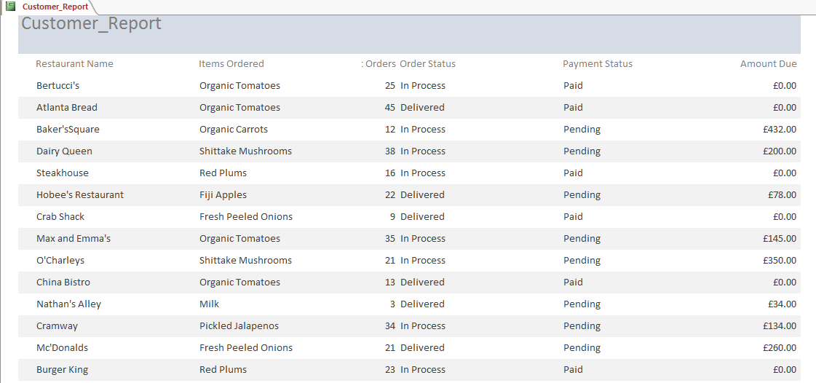

The database includes a table *Product_List*, containing all relevant variables needed for our project; *Invoice No., Restaurant Name, Items Ordered, Current Order, Order Status, Payment Status, Amount Due.*

Although, we have a handful of queries that aid users to view and analyse the data. We also have a form *Update_Product_List* that serves solely manually add items into the storage. It requires appropriate input similar with the variables *Product_List* has. As of now, our table has 15 instances as samples. These instances can be viewed easily in our report that we made *Customer_Report*, which can be represented with the screenshot above. We included only important variables to remove redundant information within the table.

**Project development and release ICT infrastructure.**

Our **version control** system was github. We used it because not unlike MS Access, it was commonly used among our peers, therefore were easily accessible for inputs. It was believed that although the repository was not private, we think that due to the We also hosted it on github for the live acceptance testing. While we used github as our version control to collaborate, we also use a cloud drive to share important and necessary files for the success of the project. In this case, **Google Drive**. We used this cloud drive because it was dependable and can be easily accessed by users without hassle. Privacy was also ensured -- the owner would invite other team members to collaborate and allow them to upload their share of the project or work together on the report.

**Whatsapp** was mainly our means of communication. We discussed about the project whenever necessary and was not constrained with time. This way we can minimise meetings and focus more on our share of the project.

**Programming languages used:**

*JavaScript*

JavaScript is most commonly used as a client side scripting language. This means that JavaScript code is written into an HTML page. When a user requests an HTML page with JavaScript in it, the script is sent to the browser and it's up to the browser to do something with it.

*JQuery*

jQuery is a fast, small, and feature-rich JavaScript library. It makes things like HTML document traversal and manipulation, event handling, animation, and Ajax much simpler with an easy-to-use API that works across a multitude of browsers.

*HTML*

HTML is a computer language devised to allow website creation.

*CSS*

Cascading Style Sheets is a style sheet language used for describing the presentation of a document written in a mark-up language.

Our project was mostly coded in Dreamweaver **IDE.** We used this because it was commonly used by the students and is the most familiar IDE we have used throughout our course.

To conduct the live testing, we used **GitHub Pages**. It helped us turn a repository into a live website tied to our project leader’s github username. To aid new team members set-up our development/release environment, we have provided steps how to host the project on github;

* Head over to GitHub.com and create a new repository, or go to an existing one.
* Click on the Create new file button.
* Name the file index.html and type some HTML content into the editor.
* Scroll to the bottom of the page, write a commit message, and commit the new file.
* Scroll to the bottom of the page, write a commit message, and commit the new file.

**Conclusion:**

In conclusion, we can say that the project has met the goals of all the initial requirements of our client. We were able to deliver a functional application along with a user database that will integrate the inventory management and the delivery of goods. This will provide a comprehensive solution for the trading company with improved logistics and low costs.